BRAND POSITIONING AUDIT
FIELD OBSERVATION & STP ANALYSIS
Women’s Ethnic Wear | Ambience Mall, Vasant Kunj | 25 August 2026
A. PROJECT DETAILS
Student Name | Palak Bansal
Team / Section | FM
Mall / Retail Marketplace | Ambience Mall, Vasant Kunj
City | New Delhi
Product Category | Women’s Ethnic Wear
Date of Visit | 25-08-2026
Brands Selected | Brand 1: CHIQUE | Brand 2: BIBA | Brand 3: AURELIA
B1. BRAND 1 — CHIQUE FIELD OBSERVATION
Brand Name | CHIQUE
Store Location | Ambience Mall, Vasant Kunj
Visit Date & Time | 25-08-2026, 6:00 PM
Store Visit Duration | 20–25 minutes
1. Price Architecture
Item | Observed Price / Evidence
Lowest-priced item — Women’s Shirt | ₹2,599 | Photo: Yes
Mid-priced item — Women’s Shirt | ₹5,500 | Photo: Yes
Highest-priced item — Women’s Dress | ₹12,000 | Photo: Yes
Overall price impression | Mid-range
2. Store Design & Atmospherics
Lighting | Bright / cool white
Flooring | Tiles
Music | No music
Display density | Moderate
Staff-to-customer ratio | Approx. staff: 2 | Approx. customers: 1
Store layout | Open
Overall atmosphere | Minimal
Key observation | The store had a clean, open and minimal design.
3. Customer Profile Observation — 10 Minutes
Approx. age range | 30+
Group type | Solo / limited footfall observed
Dress style | Casual / Indo-western
Approx. number observed | 0–1
Dominant customer profile | Females
Evidence from observation | Very limited footfall during the observation period; the customer observed was a woman aged 30+. Limitation: the visit was on a weekday evening (6:00 PM); footfall may have been higher on a weekend or during peak evening hours, so this sample should be read as directional, not conclusive.
4. Brand Communication Cues
Visible tagline(s) | No specific tagline observed in the photographs; CHIQUE store signage was visible.
Campaign / promotional words | No specific campaign wording was visible during the visit.
Signage / messaging | CHIQUE store signage.
Packaging / product copy | No specific packaging copy was visible during the visit.
Celebrity / influencer / athlete | No celebrity or influencer communication was observed.
Main message communicated | Modern, refined and contemporary women’s fashion.
Photos taken | Yes
5. Salesperson Interaction
Q1: Who is this brand popular with? | Girls and women aged around 25–30 and above.
Q2: How is this brand different from [Competitor]? | It focuses on modern, refined designs with an affordable-premium and Indo-Western fashion appeal.
Salesperson name/designation (if offered) | Sales Associate
6. Initial STP Analysis
Segmentation — possible customer groups | Segment A — Young style-first shoppers (18–25, price-sensitive, trend-led)  Segment B — Modern working women (25–45+, middle/upper-middle income, contemporary/Indo-western, aspirational + social) — CHIQUE's clear priority, see Targeting  Segment C — Occasion-only shoppers (30+, infrequent visits)
Targeting — who is the brand prioritising? | Women aged around 25–45+ seeking modern and refined ethnic/Indo-western fashion.
Targeting evidence | CHIQUE targets adult women seeking contemporary fashion because we observed a minimal modern store, a 30+ customer profile and the salesperson identified women aged 25–30 and above as a key customer group.
Positioning — one idea the brand wants to own | Modern, contemporary and refined women’s fashion.
Positioning statement | For modern women, CHIQUE is a contemporary women’s fashion brand that offers refined ethnic/Indo-western styles because its store presentation and product mix emphasise modern silhouettes and fashion-led designs.
7. Photo / Evidence Checklist
Price tag photos | ☑ Lowest ☑ Mid ☑ Highest
Store / display photos | ☑ Entrance ☑ Layout ☑ Displays
Communication photos | ☑ Signage ☑ Campaign ☑ Packaging where available
Other useful evidence | 6 field photographs included below.
CHIQUE — FIELD PHOTOGRAPHS
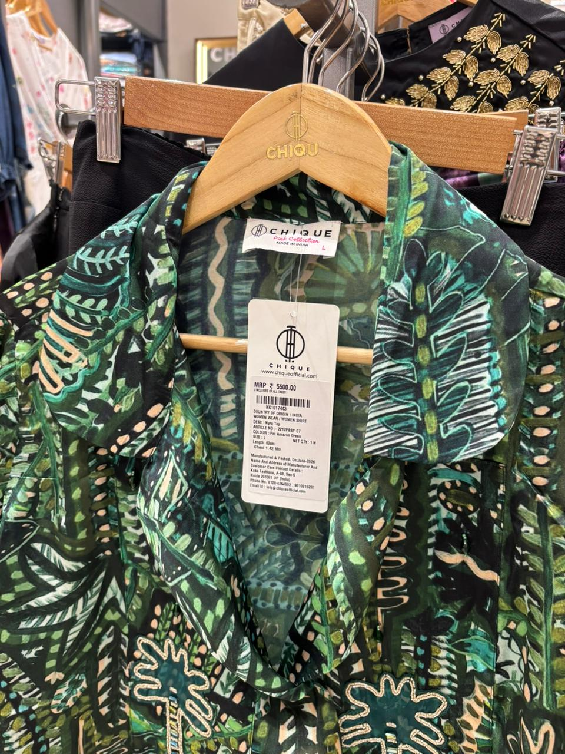  CHIQUE — Photo 1 | 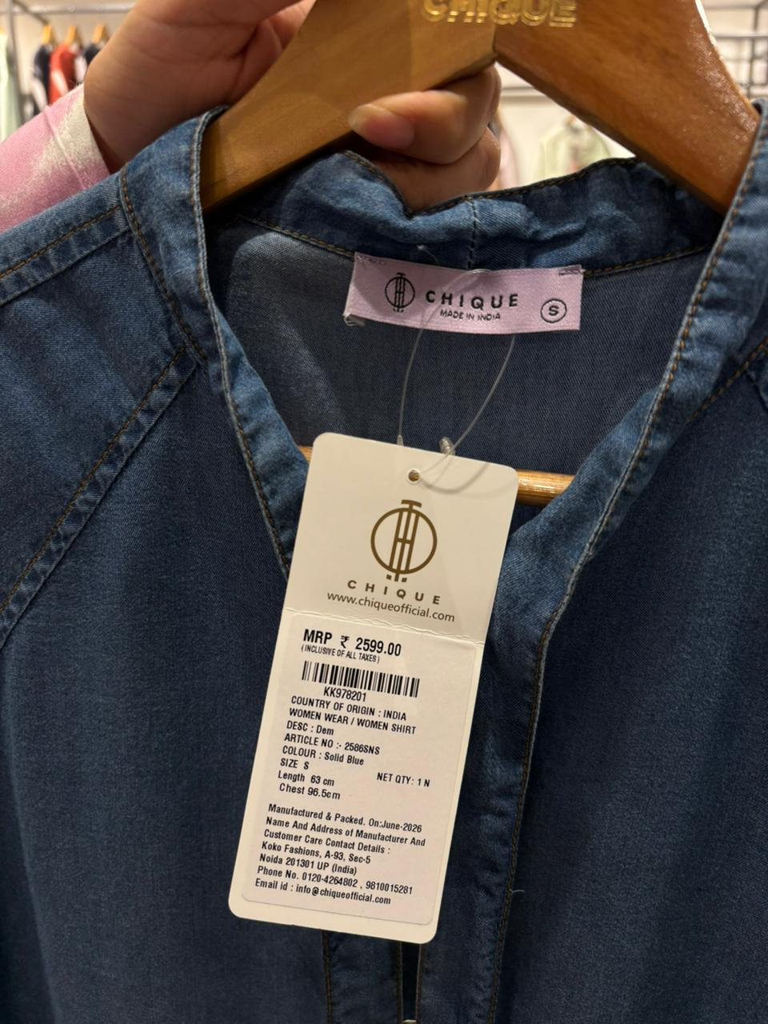  CHIQUE — Photo 2 | 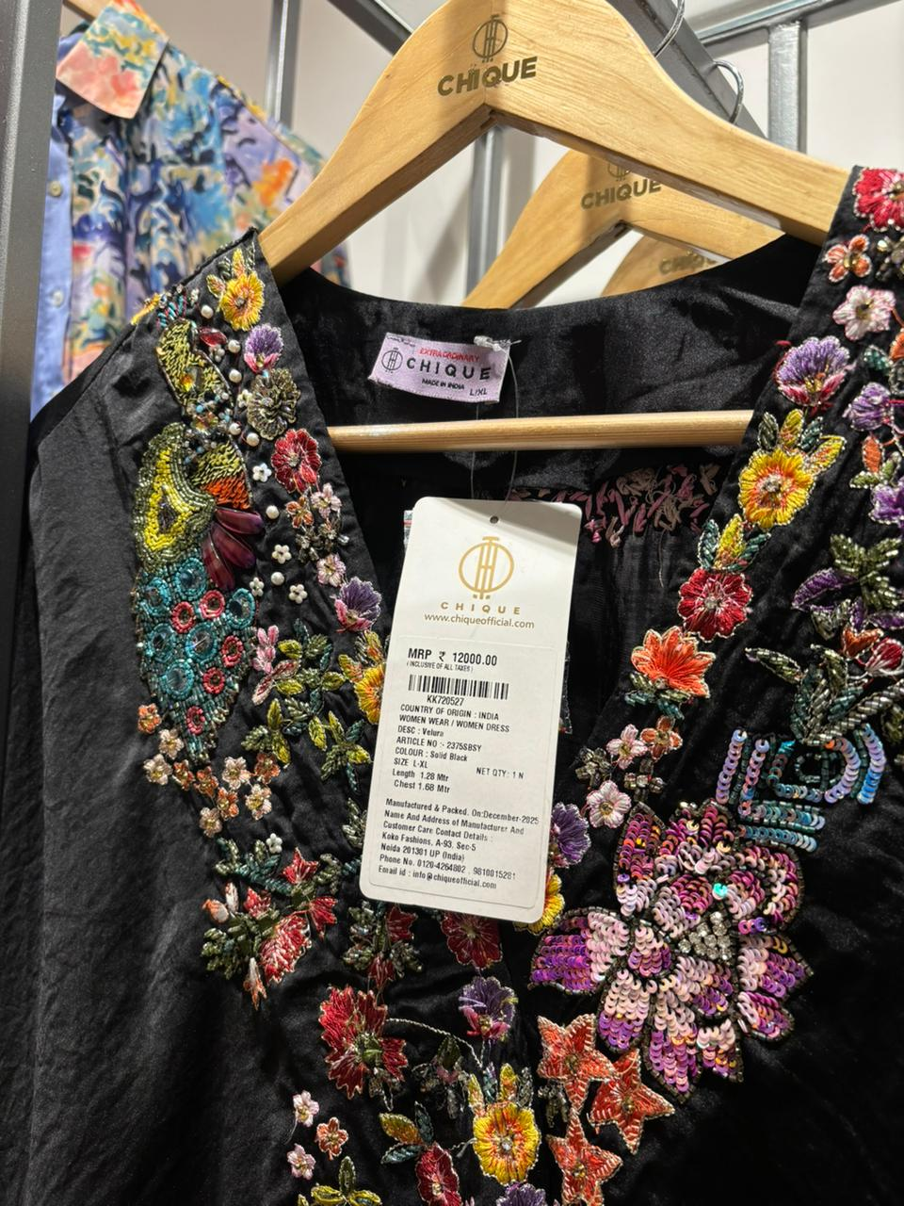  CHIQUE — Photo 3
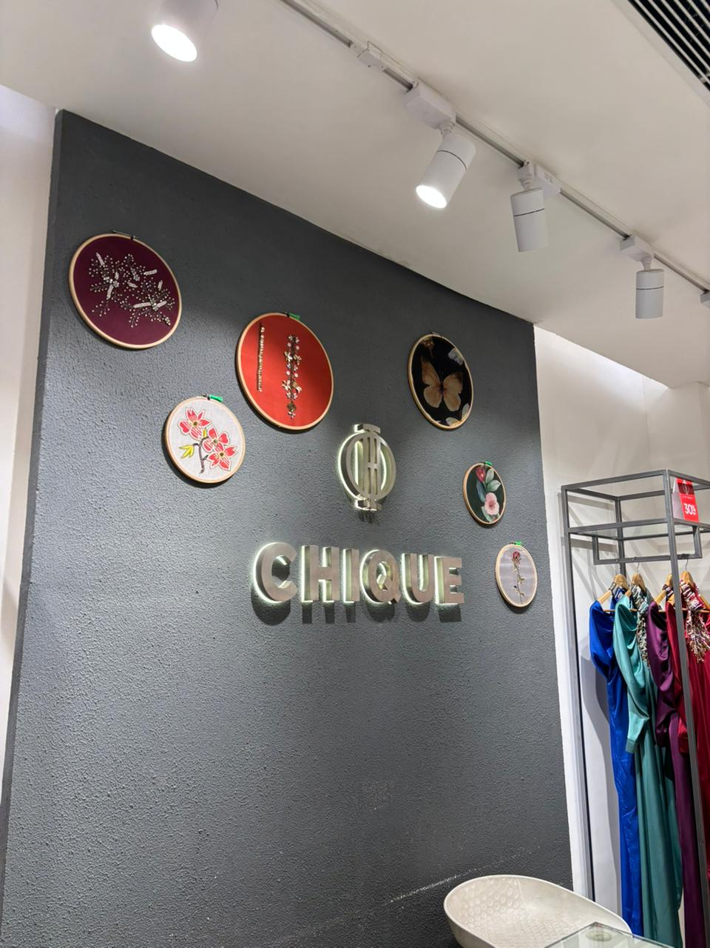  CHIQUE — Photo 4 | 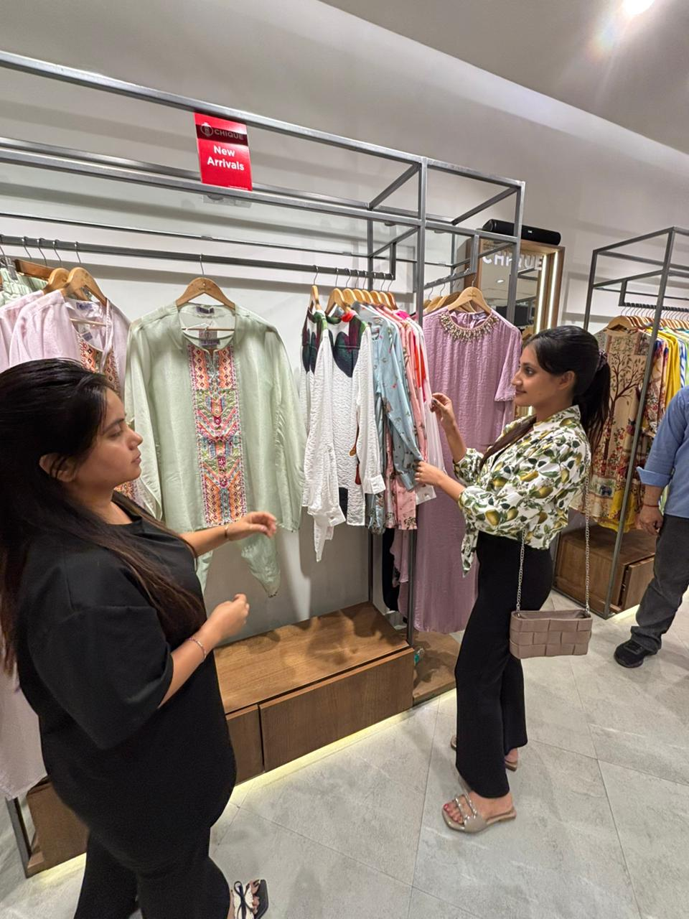  CHIQUE — Photo 5 | 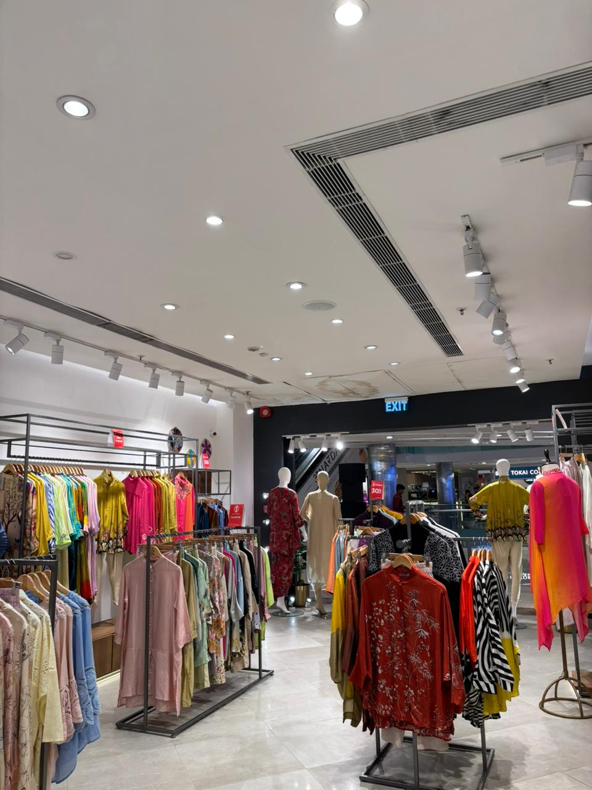  CHIQUE — Photo 6

B2. BRAND 2 — BIBA FIELD OBSERVATION
Brand Name | BIBA
Store Location | Ambience Mall, Vasant Kunj
Visit Date & Time | 25-08-2026, 7:00 PM
Store Visit Duration | 20–25 minutes
1. Price Architecture
Item | Observed Price / Evidence
Lowest-priced item — Mix and Match | ₹1,299 | Photo: Yes
Mid-priced item — Salwar Kurta Dupatta | ₹10,950 | Photo: Yes
Highest-priced item — Salwar Kurta Dupatta | ₹79,950 | Photo: Yes
Overall price impression | Mixed / wide price range
2. Store Design & Atmospherics
Lighting | Subtle / warm-toned
Flooring | Tiles
Music | Slow
Display density | Moderate to packed
Staff-to-customer ratio | Approx. staff: 3 | Approx. customers: 2
Store layout | Spacious
Overall atmosphere | Premium, traditional and occasion-focused
Key observation | Overall premium and suitable for bridal and occasion shopping.
3. Customer Profile Observation — 10 Minutes
Approx. age range | 18+
Group type | Solo / limited groups observed
Dress style | Traditional / festive
Approx. number observed | 1–2
Dominant customer profile | Females
Evidence from observation | The store had female shoppers and a premium ethnic/occasion-oriented product display; the observed customer range was 18+. Limitation: only 1–2 customers were observed in the 10-minute window; a weekday-evening visit (7:00 PM) likely understates BIBA's true footfall compared to weekends or festive periods.
4. Brand Communication Cues
Visible tagline(s) | “Rakhi Gifting Made Easy!” was visible on the store campaign poster.
Campaign / promotional words | “Get Flat 15% Off” and “Build Your Bundle Today!”
Signage / messaging | BIBA store signage with a festive Rakhi campaign.
Packaging / product copy | No specific packaging copy was visible during the visit.
Celebrity / influencer / athlete | No celebrity endorsement was observed in the captured store material.
Main message communicated | Festive, traditional and occasion-ready ethnic fashion with promotional value.
Photos taken | Yes
5. Salesperson Interaction
Q1: Who is this brand popular with? | Young girls ready to wear Fusion Fashion
Q2: How is this brand different from [Competitor]? | heavy focus on ready-to-wear vibrant festive/fusion styles, and multi-generational product expansion ranging from young girls to luxury designer capsule lines
Salesperson name/designation (if offered) | Sales Associate
6. Initial STP Analysis
Segmentation — possible customer groups | Segment A — Everyday ethnic-wear buyers (young adult, budget-conscious, ₹1,299 entry point)  Segment B — Premium/bridal & occasion shoppers (18–45+, middle-high income) — BIBA's clear priority, see Targeting  Segment C — Seasonal festive gift-buyers (promotion-driven, e.g. the observed Rakhi campaign)
Targeting — who is the brand prioritising? | Women looking for ethnic wear across everyday, festive and premium occasion needs, with a strong appeal to occasion/bridal shoppers.
Targeting evidence | BIBA targets women seeking ethnic and occasion wear because we observed a premium ethnic presentation, a female customer profile, bridal/occasion-oriented merchandise and a festive gifting campaign.
Positioning — one idea the brand wants to own | Traditional Indian fashion with a premium, occasion-ready appeal.
Positioning statement | For women seeking ethnic fashion for everyday and special occasions, BIBA is the ethnic-wear brand that combines traditional Indian style with contemporary fashion because its store offers a broad ethnic range and visibly communicates festive and occasion-led shopping.
7. Photo / Evidence Checklist
Price tag photos | ☑ Lowest ☑ Mid ☑ Highest
Store / display photos | ☑ Entrance ☑ Layout ☑ Displays
Communication photos | ☑ Signage ☑ Campaign ☑ Packaging where available
Other useful evidence | 6 field photographs included below.
BIBA — FIELD PHOTOGRAPHS
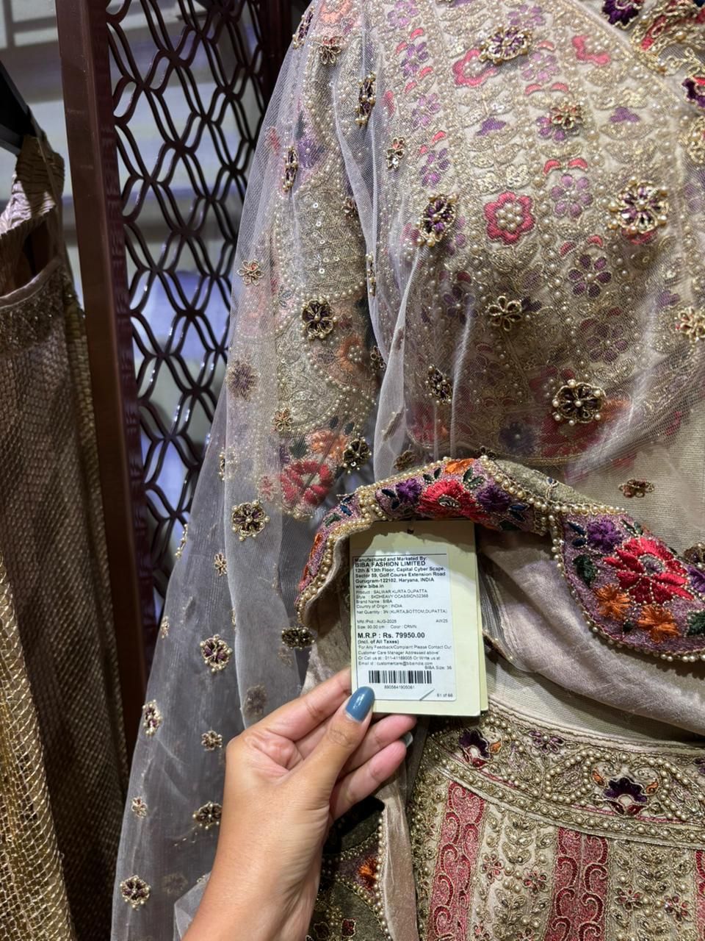  BIBA — Photo 1 | 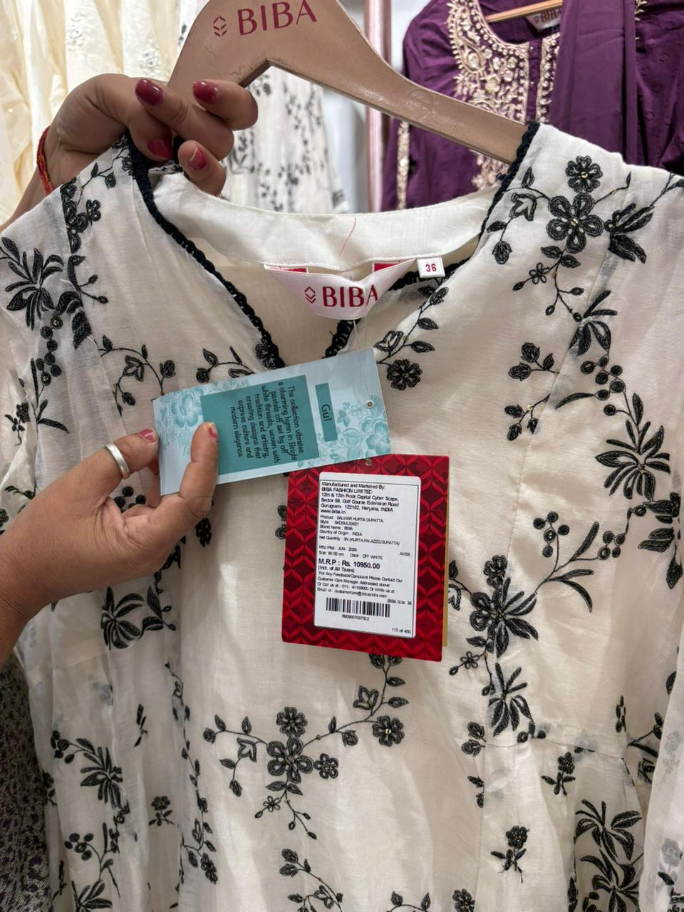  BIBA — Photo 2 | 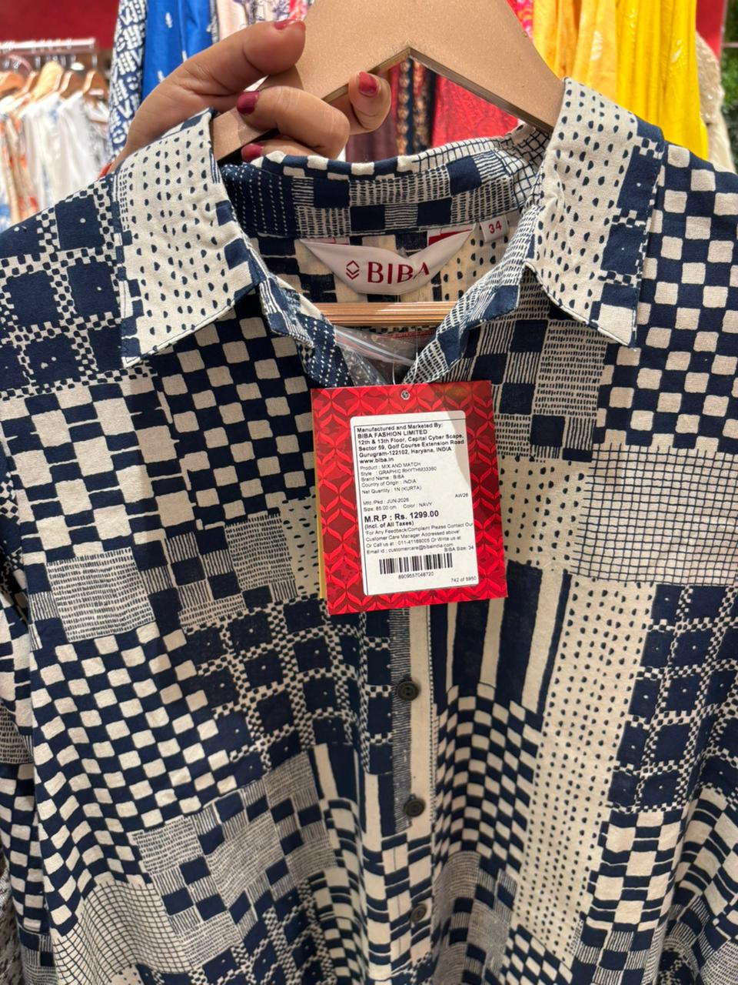  BIBA — Photo 3
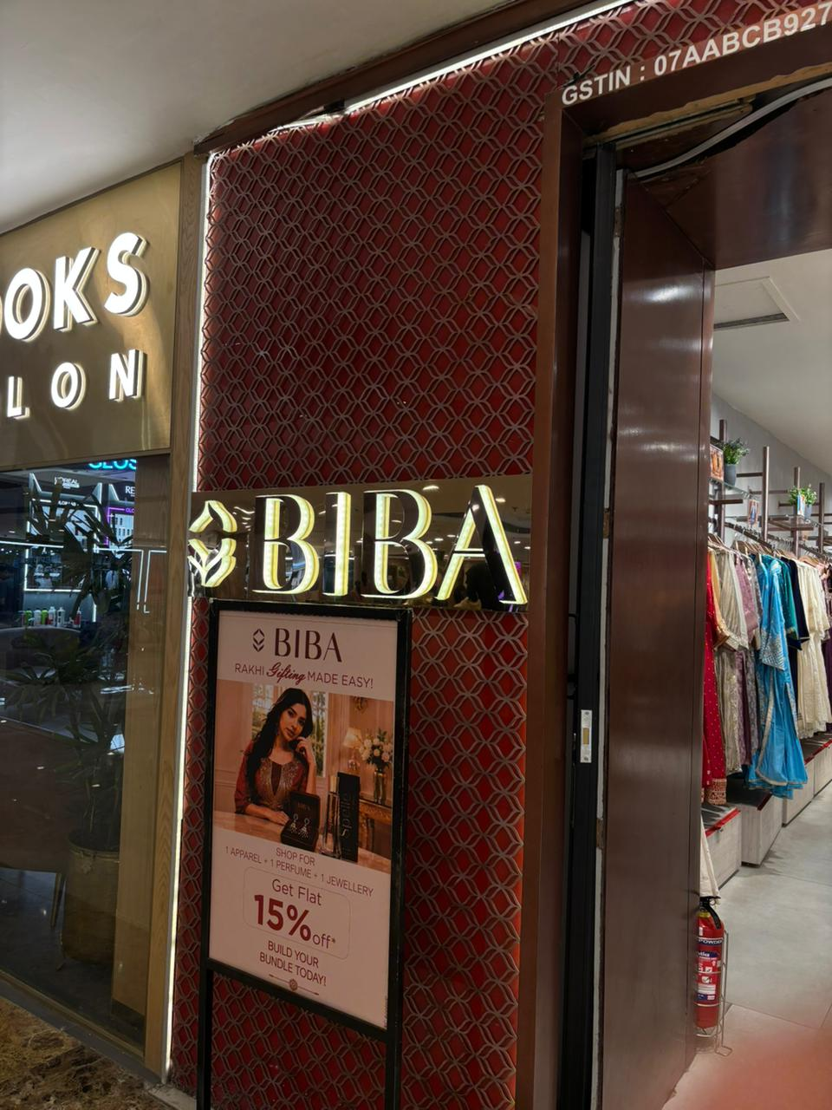  BIBA — Photo 4 | 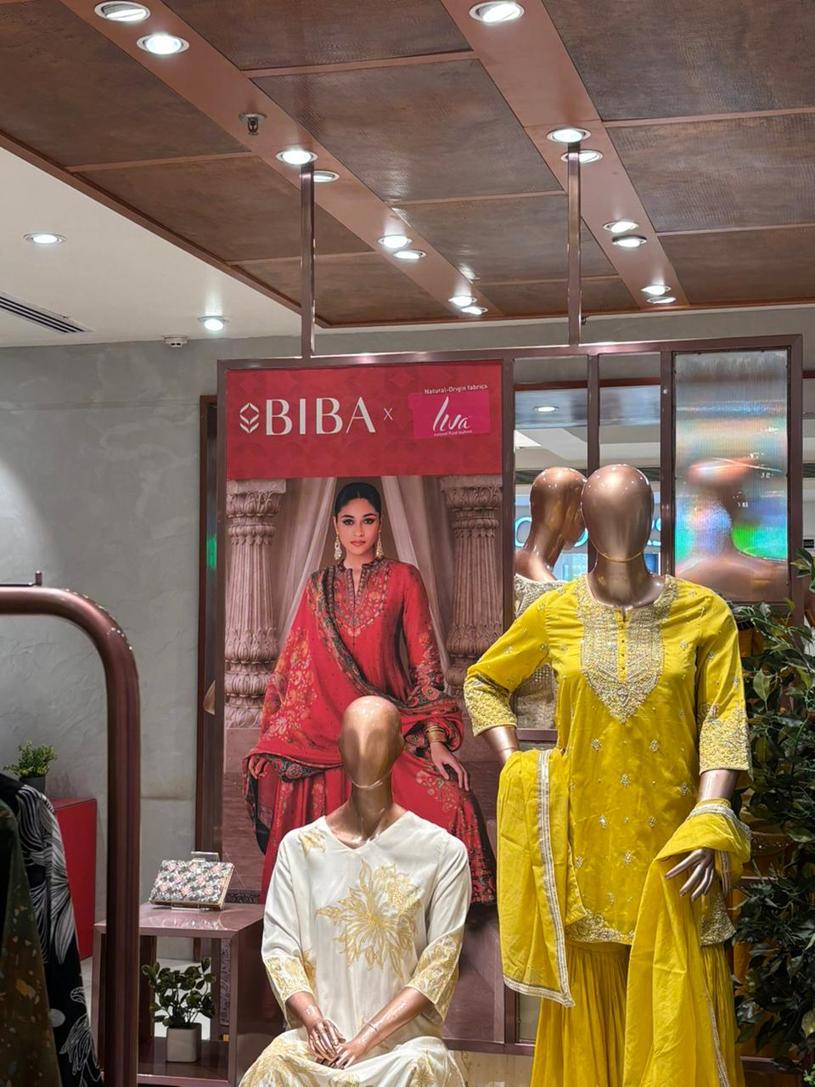  BIBA — Photo 5 | 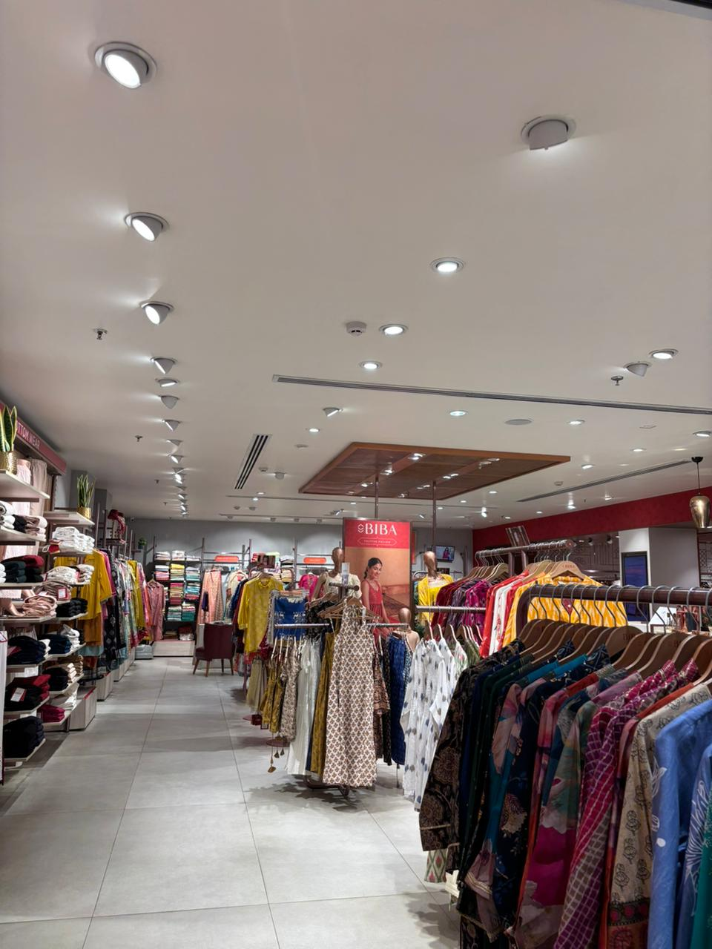  BIBA — Photo 6

B3. BRAND 3 — AURELIA FIELD OBSERVATION
Brand Name | AURELIA
Store Location | Ambience Mall, Vasant Kunj
Visit Date & Time | 25-08-2026, 6:30 PM
Store Visit Duration | 20–25 minutes
1. Price Architecture
Item | Observed Price / Evidence
Lowest-priced item — Kurta | ₹1,399 | Photo: Yes
Mid-priced item — Kurta Bottom & Jacket | ₹8,999 | Photo: Yes
Highest-priced item — Skirt & Dupatta | ₹19,999 | Photo: Yes
Overall price impression | Mixed / mid-range to premium
2. Store Design & Atmospherics
Lighting | Bright/warm display lighting
Flooring | Tiles
Music | No music
Display density | Moderate / varied
Staff-to-customer ratio | Approx. staff: 4 | Approx. customers: 3
Store layout | Large/spacious
Overall atmosphere | Elegant, festive and versatile
Key observation | Large store with multiple product varieties; suitable for party and function shopping.
3. Customer Profile Observation — 10 Minutes
Approx. age range | 30–40
Group type | Solo/couples / small groups
Dress style | Indo-western / traditional
Approx. number observed | 4–5
Dominant customer profile | Females
Evidence from observation | The store had a visible female customer base aged approximately 30–40 and a strong variety of ethnic and occasion-oriented products.
4. Brand Communication Cues
Visible tagline(s) | No separate tagline was visible; the store prominently displayed the AURELIA brand name.
Campaign / promotional words | No specific promotional campaign wording was visible during the visit.
Signage / messaging | AURELIA store signage; Aditya Birla Fashion branding was also visible.
Packaging / product copy | No specific packaging copy was visible during the visit.
Celebrity / influencer / athlete | A female model was used in the store visual; no specific celebrity association was identified.
Main message communicated | Elegant, versatile Indian/Indo-western wear for modern women and occasions.
Photos taken | Yes
5. Salesperson Interaction
Q1: Who is this brand popular with? | People purchasing for parties, marriages etc.
Q2: How is this brand different from [Competitor]? | Deals in multiple variety. (Limitation: the salesperson did not name a specific competitor despite being asked; this response is recorded as given, without embellishment.)
Salesperson name/designation (if offered) | Sales Associate
6. Initial STP Analysis
Segmentation — possible customer groups | Segment A — Everyday/office ethnic-wear buyers (working women, functional needs)  Segment B — Occasion/party & wedding shoppers (30–40+, middle-upper income) — AURELIA's clear priority, see Targeting  Segment C — Variety-seekers wanting broad wardrobe options across multiple occasions
Targeting — who is the brand prioritising? | Women around 30–40+ seeking variety in ethnic and Indo-western wear, particularly for parties, weddings and functions.
Targeting evidence | AURELIA targets occasion-oriented adult women because we observed 30–40-year-old female shoppers, a large variety of products and the salesperson specifically mentioned parties and marriages.
Positioning — one idea the brand wants to own | Variety-driven, elegant ethnic and Indo-western occasion wear.
Positioning statement | For modern women shopping for occasions, AURELIA is the ethnic-wear brand that offers elegant and versatile choices because the store provides a wide product variety and the salesperson highlighted parties and marriages as key purchase occasions.
7. Photo / Evidence Checklist
Price tag photos | ☑ Lowest ☑ Mid ☑ Highest
Store / display photos | ☑ Entrance ☑ Layout ☑ Displays
Communication photos | ☑ Signage ☑ Campaign ☑ Packaging where available
Other useful evidence | 6 field photographs included below.
AURELIA — FIELD PHOTOGRAPHS
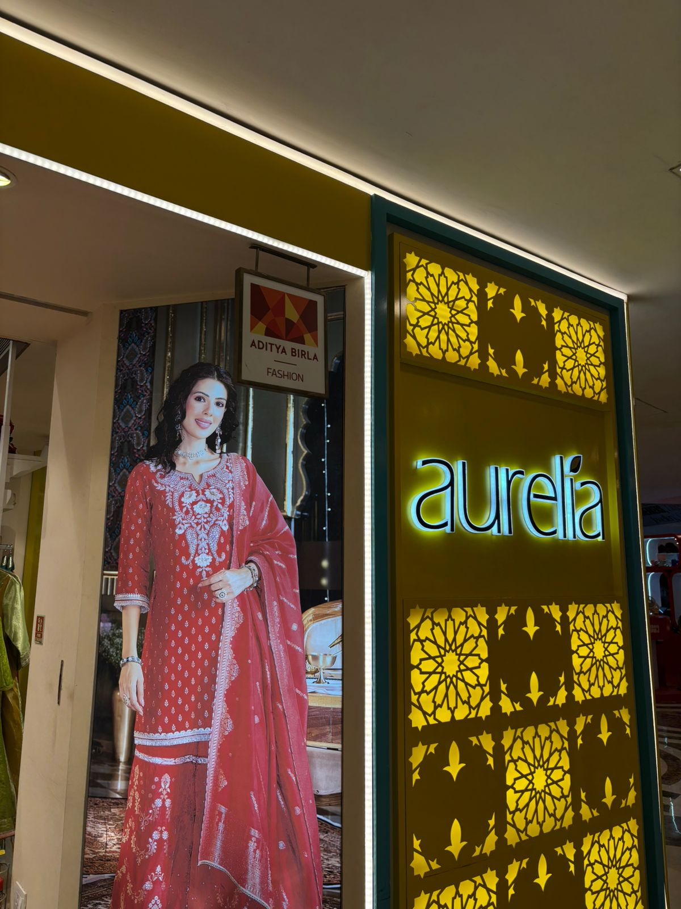  AURELIA — Photo 1 | 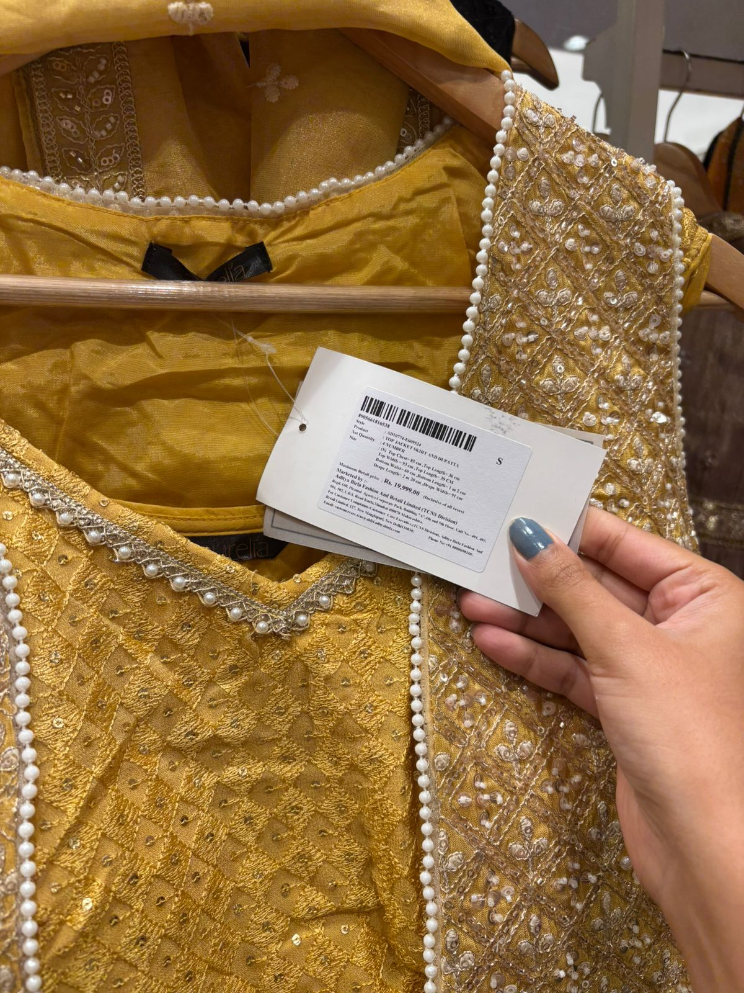  AURELIA — Photo 2 | 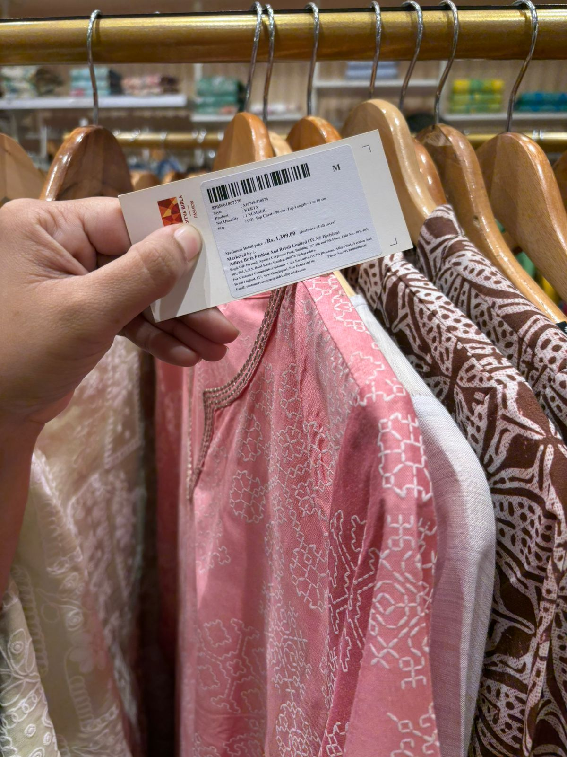  AURELIA — Photo 3
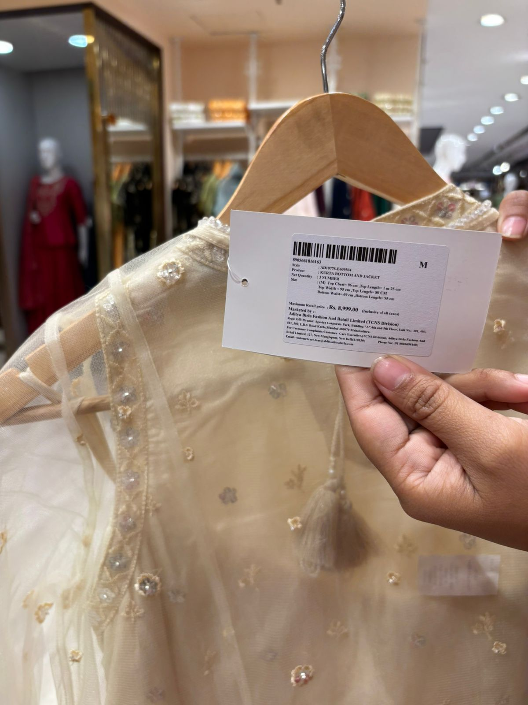  AURELIA — Photo 4 | 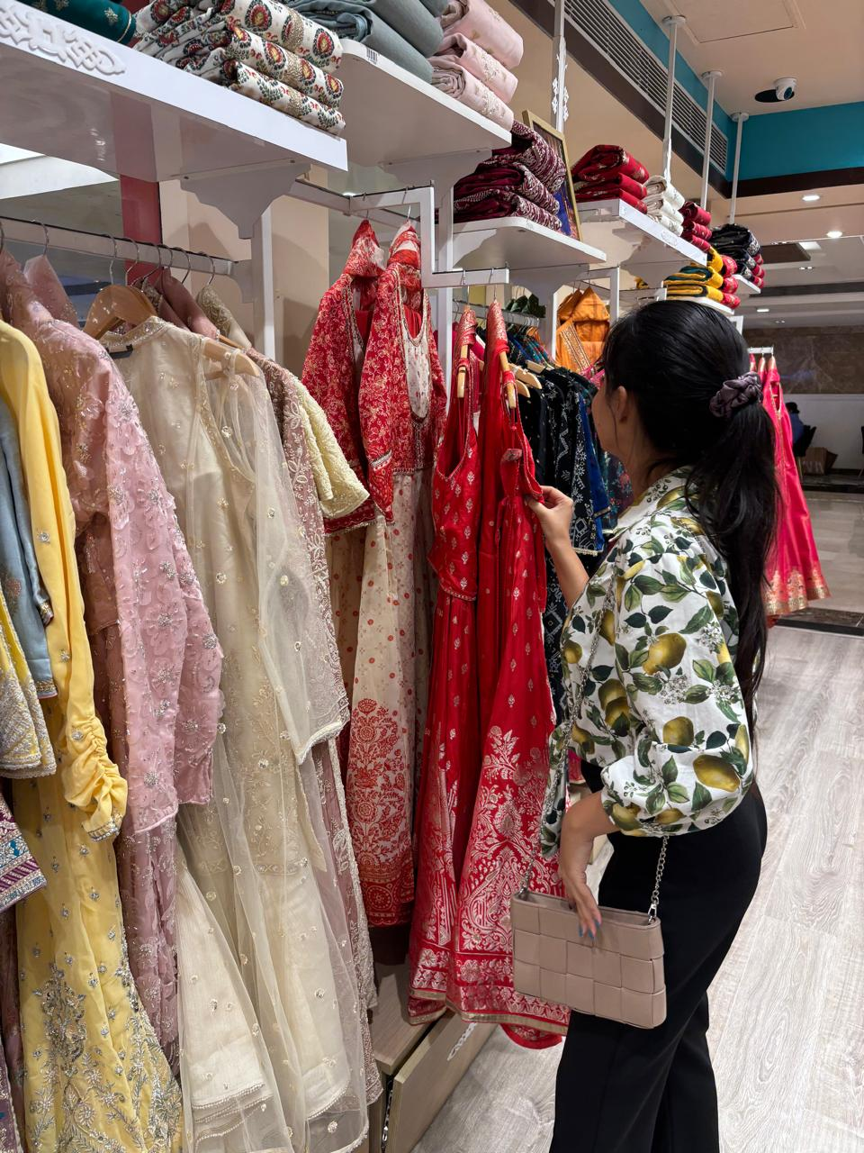  AURELIA — Photo 5 | 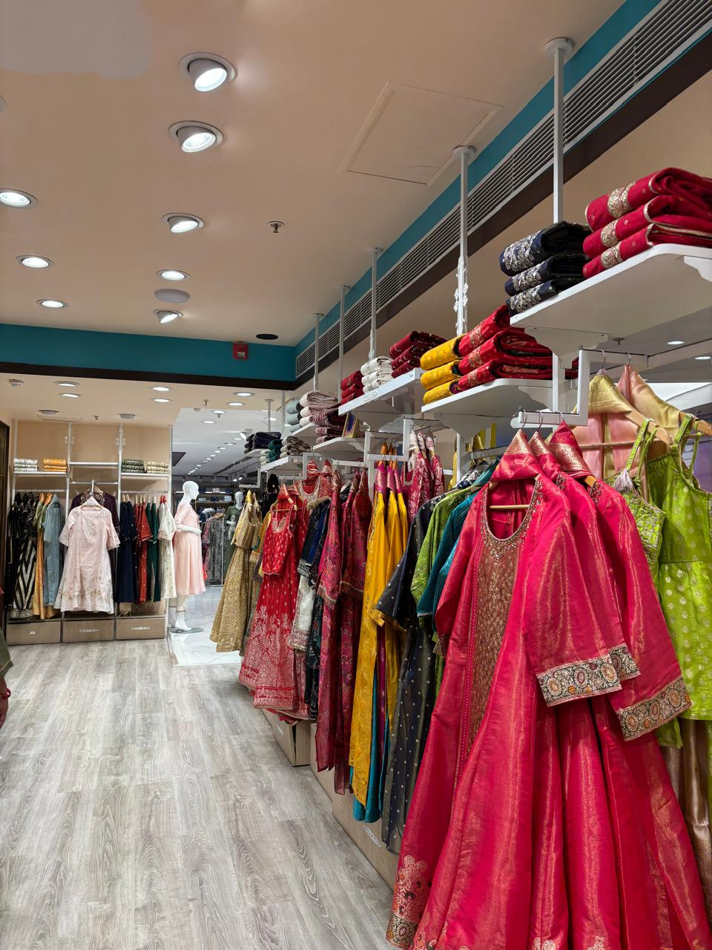  AURELIA — Photo 6

C. THREE-BRAND COMPARISON
Criteria | CHIQUE | BIBA | AURELIA
Price architecture | Mid-range to premium; ₹2,599–₹12,000 | Very wide range; ₹1,299–₹79,950 | Mid-range to premium; ₹1,399–₹19,999
Customer profile | Women 30+; limited footfall observed | Women 18+; limited footfall; occasion-oriented | Women 30–40; stronger observed footfall
Store atmosphere | Minimal, modern, refined | Premium, traditional, occasion-focused | Large, elegant, festive and versatile
Key communication | Modern/contemporary fashion; CHIQUE signage | Rakhi gifting + 15% off + bundle promotion | Elegant ethnic/Indo-western visual merchandising
Main target segment | Modern women 25–45+ | Women seeking ethnic wear across everyday/festive/occasion needs | Women 30–40+ shopping for parties, weddings and functions
Purchase motivation | Aspirational + social | Aspirational + social + functional | Aspirational + functional + social
Positioning idea | Modern, contemporary and refined fashion | Traditional Indian fashion with premium occasion appeal | Variety-driven, elegant occasion wear
Key differentiator | Minimal contemporary/Indo-western identity | Strong ethnic heritage + broad occasion range | Large variety and strong occasion relevance
D. FINAL STRATEGIC COMPARISON
Where do the 3 brands overlap? | All three target women looking for fashionable ethnic/Indian wear and use a mix of traditional and contemporary styling. All three also have a strong aspirational/social purchase element for special occasions.
Where do they diverge? | CHIQUE appears more modern, minimal and contemporary; BIBA has the strongest traditional and premium occasion/bridal appeal; AURELIA differentiates through variety and versatility for parties, weddings and functions.
Which brand has the sharpest positioning? | BIBA
Why is its positioning strongest / most defensible? | The store communicated a clear ethnic and occasion-led identity through premium merchandise, bridal/occasion relevance and the visible “Rakhi Gifting Made Easy!” campaign. This gives BIBA a clearer emotional and occasion-based association than the more variety-led AURELIA and the more contemporary/fashion-led CHIQUE.
E. AI AUDIT & REALITY CHECK
Note: The full AI-generated STP outputs are reproduced in Appendix A. The points below compare specific claims made in that AI output against the field evidence recorded in this report.
CHIQUE — AI vs Reality
Brand | CHIQUE
What did AI get right? | Appendix A describes CHIQUE's buyers as "modern, fashion-conscious women who value contemporary design, self-expression and a refined appearance" — this matches the minimal, contemporary store we observed and lines up with the salesperson's statement that the brand is popular with women aged 25–30 and above.
What did AI miss or get wrong? | Appendix A's segmentation describes buyers as women who "mix traditional Indian influences with contemporary/Indo-western fashion," implying a visible ethnic component. Our visit found almost no traditional or Indo-western cues on the floor — the store read as purely modern/contemporary — and footfall was only 0–1 customers in 10 minutes, far thinner than the established customer base the AI's framing implies.
What could AI NOT know without visiting the store? | AI could not know the actual minimal store atmosphere, the very limited footfall during the observation period, or the salesperson’s specific customer description.
Our final judgement | Field evidence suggests CHIQUE’s strongest observed distinction is modern, refined and contemporary fashion rather than purely traditional ethnic wear.
BIBA — AI vs Reality
Brand | BIBA
What did AI get right? | Appendix A's positioning statement — that BIBA "combines traditional Indian aesthetics with contemporary fashion" through an "established ethnic range" and "occasion-focused collections" — matches what we saw: a premium, occasion-oriented store with strong ethnic heritage cues throughout.
What did AI miss or get wrong? | Appendix A's segmentation treats "premium occasion shoppers" as one sub-segment among several, which understates how strongly the assortment skewed toward that group — our observed highest price was ₹79,950, and the floor was dominated by bridal/occasion merchandise rather than everyday ethnic wear.
What could AI NOT know without visiting the store? | AI could not know the specific store campaign “Rakhi Gifting Made Easy!”, the 15% bundle offer, the observed premium/bridal feel, or the limited customer footfall at that particular time.
Our final judgement | Field evidence strengthens BIBA’s positioning as a traditional, premium and occasion-ready ethnic-wear brand.
AURELIA — AI vs Reality
Brand | AURELIA
What did AI get right? | Appendix A's positioning statement describes AURELIA as offering "versatile Indian and Indo-western clothing" with "occasion-appropriate styles" — this matches the wide product variety and elegant, festive store atmosphere we observed.
What did AI miss or get wrong? | Appendix A frames AURELIA's buyers as "working women, modern homemakers and occasion shoppers" seeking clothing "for everyday use as well as festive and social occasions" — but when asked directly, the salesperson described the brand as popular with "people purchasing for parties, marriages etc.," with no mention of everyday or office wear. Field evidence points much more strongly to an occasion-only positioning than the AI's broader everyday-plus-occasion framing.
What could AI NOT know without visiting the store? | AI could not know the actual 4–5 observed customers, the 30–40 age profile, the large store layout, or the salesperson’s direct statement about parties and marriages.
Our final judgement | Field evidence suggests AURELIA’s strongest observed position is variety-driven, elegant occasion wear for modern women.
F. FINAL SUBMISSION CHECKLIST
☑ One product category selected — Women’s Ethnic Wear
☑ Three competing brands studied in the same retail environment — CHIQUE, BIBA, AURELIA
☑ Lowest, mid and highest price photos collected for each brand
☑ Store design and atmosphere recorded for each brand
☑ 10-minute customer observation completed / field observation recorded for each brand
☑ Brand communication/signage photos included where available
☑ Salesperson questions documented with the responses obtained during the store visits
☑ STP analysis completed using field evidence
☑ Three brands compared
☑ Full AI STP outputs included as Appendix A
☑ AI vs reality critique completed for all 3 brands
IMPORTANT: Field observations and photographs are the primary evidence. The analysis is based on the observations and salesperson responses collected during the store visits.

APPENDIX A — AI-GENERATED STP OUTPUTS
Prompt used: “Generate a detailed STP analysis for [Brand] in the [category] market in India. Include segmentation variables, likely target segments, and a positioning statement.”
CHIQUE
Segmentation:
• Demographic: Women primarily in the 25–45+ age group; middle to upper-middle income.
• Psychographic: Modern, fashion-conscious women who value contemporary design, self-expression and a refined appearance.
• Lifestyle: Urban women who mix traditional Indian influences with contemporary/Indo-western fashion.
• Behavioural: Buyers motivated by style, self-expression, occasion dressing and perceived design value.

Targeting:
CHIQUE is likely to target modern urban women who want contemporary, refined and fashion-forward women’s wear with a blend of traditional and western influences.

Positioning:
For modern, fashion-conscious women, CHIQUE is a contemporary women’s fashion brand that offers refined and distinctive styles because its product range combines modern silhouettes, prints and Indo-western influences with an emphasis on self-expression.

BIBA
Segmentation:
• Demographic: Women across young-adult and adult age groups; middle to higher-income consumers, with premium occasion shoppers as an important sub-segment.
• Psychographic: Women who value Indian heritage, elegance, fashion and occasion dressing.
• Lifestyle: Consumers shopping for everyday ethnic wear, festive occasions, weddings, gifting and special events.
• Behavioural: Buyers motivated by tradition, occasion relevance, social presentation, style and convenience.

Targeting:
BIBA is likely to target women seeking fashionable Indian ethnic wear across everyday, festive and occasion-led needs, including consumers looking for premium and bridal/celebratory outfits.

Positioning:
For women who want fashionable Indian ethnic wear, BIBA is the ethnic-wear brand that combines traditional Indian aesthetics with contemporary fashion because of its established ethnic range, occasion-focused collections and strong association with Indian wear.

AURELIA
Segmentation:
• Demographic: Modern Indian women, particularly around 25–40+, with middle to upper-middle income.
• Psychographic: Women who want ethnic fashion that is stylish, comfortable and easy to wear.
• Lifestyle: Working women, modern homemakers and occasion shoppers seeking versatile Indian and Indo-western outfits.
• Behavioural: Buyers motivated by comfort, variety, versatility, style and occasion suitability.

Targeting:
AURELIA is likely to target modern Indian women who want versatile ethnic and Indo-western clothing for everyday use as well as festive and social occasions.

Positioning:
For modern Indian women, AURELIA is an ethnic-wear brand that offers stylish and versatile Indian and Indo-western clothing because it provides a broad range of coordinated outfits and occasion-appropriate styles that balance traditional elements with contemporary fashion.

